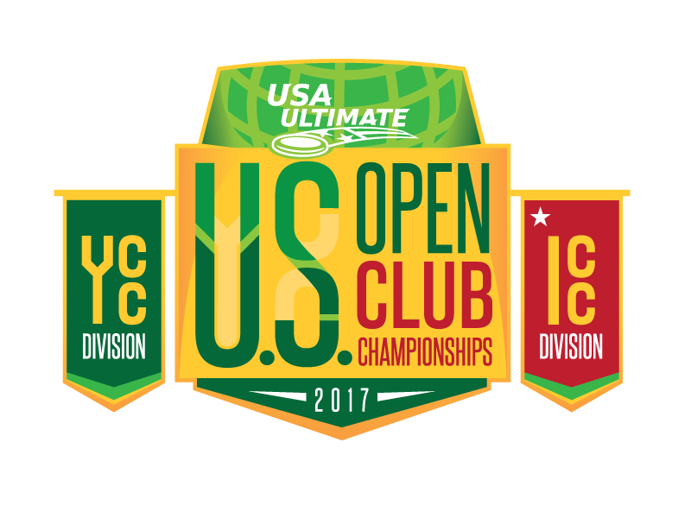
2017 U.S. Open Club Championships
Team Information Form

Forms are due Wednesday, July 5.
Return info form in Google Doc or Word format to media@usaultimate.org.
Do NOT submit as PDF.

Note: This deadline is NON-NEGOTIABLE.

To submit as Word doc:  Click “File” in the upper left of the menu bar and hover over “Download as.”  Click on Microsoft Word.  Open the file to input your team’s information.  Save the document and return as an attachment to media@usaultimate.org. | To submit as a Google doc:  Click “File” in the upper left of the menu bar and select “Make a copy.”  Click “OK” on the “Copy document” pop-up window.  Enter your team’s information into the document.  When you are finished, click the blue “Share” button in the top right corner of your doc.  Enter media@usaultimate.org into the empty field in the pop-up window.  Click the blue “Done” button.

TEAM CONTACTS
Please list two team contacts below.

 | Full Name | Email Address | Cell Phone
1. | Ben Pelleg | ben.e.pelleg@gmail.com | 610-453-8181
2. | Patrick Sherlock | pasherlo@gmail.com | 732-814-9563

COACH(ES)
- Please list any coaches below.
- All U.S. and Canadian coaches must have a current Coach Level Membership and current Green Light NCSI Background Check. All other coaches must get approval from their National Federation and sign off on the USA Ultimate Code of Ethics and Spirit of Coaching documents.
- Limit three.

 | Full Name | USAU ID | Email | Coach Member? (Y/N) | Certified? (Y/N)
1. | Patrick Sherlock | 104310 | pasherlo@gmail.com | Y | Y
2.
3.

SPIRIT CAPTAIN
This is a new position at USA Ultimate championship-level events. Specific responsibilities will be emailed to appointed individuals. Spirit captains should be leaders, strong communicators and efficient in the completion of tasks (i.e., filling out and handing in spirit score sheets).

 | Full Name | Email
1. | Allysha Dixon | adixon923@gmail.com

TEAM SUPPORT PERSONNEL
Please list any team support personnel below. All team support personnel will need to sign the sideline access agreement provided electronically.
Limit two.

 | Full Name | Email
1. | Ray DeSabato | ray.desabato@gmail.com
2. | Pat DeSabato | ray.desabato@gmail.com

TEAM MEDIA PERSONNEL
One person per team will be allowed sideline access as a team photographer/videographer. He or she must sign USA Ultimate’s Recording Partnership Agreement and pick up a credential either at team registration or at the Info Tent at the field site.

Name: Email:

Coaches, Team Support Personnel and Team Media Personnel will be required to have credentials at the event at all times for sideline access. Credentials will only be provided to individuals listed in the above section of this form. Failure to include this information with your on-time, completed form will result in any unlisted individuals being denied sideline access at the event. Contact leah@hq.usaultimate.org with questions.

ROSTER INFORMATION
Please fill in the blanks below.

Team Name: AMP
City/ST: Philadelphia, PA
Website: phillyamp.com
Twitter: @phillyAMP
Captains: Andrea DeSabato, Ben Pelleg, Stephen Ng, Emily Shields

Players:
(Must be in order by jersey number, from lowest to highest)

# | First Name | Last Name | Years with Team | Height |  | Wt. | Age | Hometown |  | Country | College Team | Previous Club Teams
 |  |  |  | Ft. | In. |  |  | City | ST
1 | Bobby | Roos | 3 | 5 | 11 | 170 | 28 | Allentown | PA | USA | Kutztown University | Stark Appeal; Hooray
2 | Matt | Zumbrum | 6 | 6 | 3 | 175 | 32 | Hanover | PA | USA | University of Delaware
3 | Nichoas | Purifico | 5 | 5 | 9 | 156 | 34 | Philadelphia | PA | USA | University of Delaware | Rage; Truck Stop; Hooray; Southpaw
4 | Raha | Mozaffari | 12 | 5 | 4 | 140 | 31 | Philadelphia | PA | USA | University of Pennsylvania
5 | Justin | Carter | 1 | 6 | 2 | 180 | 24 | Lansdale | PA | USA | Lehigh University | Garden State
6 | Kelsey | Devlin | 3 | 5 | 5 | 130 | 24 | Philadelphia | PA | USA | University of Delaware | Green Means Go
7 | Steve | Rosso | 1 | 5 | 11 | 165 | 27 | Malvern | PA | USA | Franklin & Marshall | Bang
8 | Luke | Ryan | 2 | 6 | 1 | 175 | 25 | Maplewood | NJ | USA | Saint Joseph's University | Bang; Citywide Special
9 | Andrea | DeSabato | 8 | 5 | 6 | 130 | 30 | Wynnewood | PA | USA | Temple University
11 | Ryan | Flamberg | 2 | 6 | 1 | 155 | 24 | Blue Bell | PA | USA | University of California, Los Angeles | Renegade
13 | Nico | Lake | 3 | 5 | 11 | 165 | 23 | Wynnewood | PA | USA | Georgetown University | Gave,; Hypnotoad
14 | Stuart | Hean | 3 | 6 | 1 | 180 | 25 | Upper Marlboro | MD | USA | Haverford College | Citywide Special
16 | Rob | Robinson | 2 | 6 | 0 | 175 | 27 | Ridley Park | PA | USA | West Chester University | Bang
17 | Stephen | Ng | 4 | 5 | 7 | 150 | 26 | Phoenixville | PA | USA | Temple University | Bitmap; Shinigami
18 | Emily | Shields | 3 | 5 | 4 | 120 | 24 | North Caldwell | NJ | USA | Tufts University | Wild Card
19 | Anna | Thompson | 1 | 5 | 3 | 130 | 20 | Bellevue | WA | USA | University of Pennsylvania | Freeze, Green Means Go
20 | Ben | Pelleg | 8 | 5 | 11 | 160 | 30 | Haverford | PA | USA | Cornell University
21 | Linda | Morse | 2 | 5 | 9 | 160 | 21 | Havertown | PA | USA | University of Pittsburgh | Green Means Go
22 | Allysha | Dixon | 3 | 5 | 3 | 126 | 24 | Spring Valley | NY | USA | Philadelphia University | Tramp Stamp
23 | Natalie | Bova | 2 | 5 | 3 | 115 | 21 | Havertown | PA | USA | University of Delaware
24 | Danielle | Walsh | 1 | 5 | 8 | 135 | 27 | Edgewater | FL | USA | Wake Forest University | Green Means Go
29 | Sarah | Johnson | 2 | 5 | 7 | 155 | 28 | Canton | MI | USA | Michigan State University
33 | Calvin | Trisolini | 3 | 6 | 1 | 160 | 22 | Hillsborough | NC | USA | Haverford College | Triforce (YCC)
36 | Carolyn | Normile | 3 | 5 | 3 | 125 | 22 | Philadelphia | PA | USA | University of Pittsburgh | Bang
46 | Austin | Bonelli | 3 | 5 | 9 | 150 | 28 | Roxbury | NJ | USA | The College of New Jersey | 7 Express
79 | Michael | Ing | 3 | 6 | 1 | 180 | 20 | Bryn Mawr | PA | USA | University of Pittsburgh | Forge (YCC)
88 | Matt | Carter | 3 | 5 | 9 | 150 | 22 | Warminster | PA | USA | George Mason University | Bitmap

INDIVIDUAL SPIRIT AWARD NOMINATION

Please nominate one player from your team for the individual spirit award.
Mixed teams: Please nominate one male and one female spirit award winner.

Spirit Award Nominee(s): Linda Morse and Matt Carter

TEAM HISTORY
Please provide a brief overview of your team's history.

Year Team Founded: Founded as Donkey Bomb in 2000, competing as AMP since 2006.
Championships Won:
Major Awards Won by Players:

Please provide a brief overview of your team’s history. This must be NO LONGER than 150 words.

(USA Ultimate reserves the right to edit based on space available and content suitability for public distribution. Team histories are intended to provide relevant historical information to members of the media. Histories that do not contain relevant information may not be published.)

Team History:
AMP is proud to represent the Founders Section and Philadelphia at the U.S. Open for the third time. Since 2006, AMP has qualified for 11 USA Ultimate National Championships and competed at the 2010 World Ultimate Club Championships in Prague, Czech Republic.

TEAM LOGO
If you have a team logo, please send it to media@usaultimate.org along with this form. Please send your team logo as either a high resolution jpeg (3" x 3" at 300 dpi), or a vector-based file with any fonts outlined (.eps or .pdf).

JERSEY COLORS
Light Jersey Color: White
Dark Jersey Color: Red
Other Jersey Color:

